Website Layout

1. Oregon Wine and Data Analysis – Landing Page
   1. Cork or wine bottle banner
   2. Oregon Wine Regions
      1. Images: Wine Regions
      2. Tableau: Production by country
   3. Wine Production in Oregon
      1. ~~Tableau: Production by region~~
      2. Tableau: Wine Type Production
      3. Information:

Oregon is home to over XXXX vineyards and XXXX wineries as of 202XXX! Due to the great number of vineyards located in Yamhill Count

* + - 1. How many vineyards
      2. Types of wine we’re focusing on
      3. Facts about wine production in Oregon?
  1. Wine Ratings
     1. Images: Photo of Robert Parker

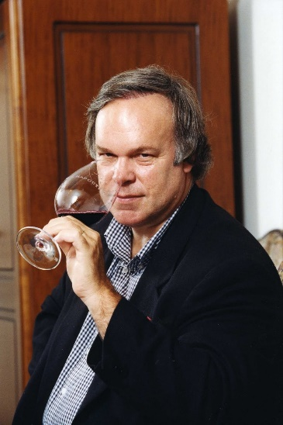

* + 1. Information:

Wine ratings have become an easy way for consumers and the industry to understand what they’re about to taste. The 100-point scale is the most common and what our website uses.

It was first developed by a lawyer named Robert Parker in 1984 after starting the newsletter *The Wine Advocate*. He wanted to develop a system that was straight forward and provide both experts and casual consumers a general expectation of what they’re about to taste. He began using a standardized system of a mathematical grade paired with 2-3 sentences per single glass of wine tasted. He always took great lengths to ensure the integrity of his ratings by paying for the wine personally and never accepting gifts.

Over the years his system was modified to include the following traits of wine: appearance, consistency, nose, taste, complexity, varietal representation and even including room for improvement along with the mathematical score. The 100-point system has long since been adopted globally with several different wine publications like *Wine Enthusiasts* and *Wine Spectator*.

The mathematical ratings for wine is as follows:

96 – 100 – Extraordinary

90 – 95 – Outstanding

80 – 89 – Barely Above Average to Very Good

70 – 79 – Average

60 – 69 – Below Average

50 – 59 – Unacceptable

Fun fact! Throughout Parker’s tasting and rating career he has tasted over 220,000 wines and has granted a perfect 100-point score to only 76 wines.

Some definitions that consumers may find helpful when reading reviews:

* + - * Tannins – Chemical compound that is responsible for the ‘dry’ mouthfeel found in wine. It is found in grape skins, seeds, stems, and inside of the wooden barrels that are used during the wine aging process. Since red wine is made from the entire grape (and sometimes stem) they will typically have a higher tannin amount than white, which just uses the juice of the grape.
      * Sweet - Higher amount of residual sugar from the fermentation process.
      * Dry - Higher amount of tannins which will cause the ‘dry’ sensation in the mouth after drinking. Typically little to no residual sugar from the fermentation process.
      * Red – Wine that is made with the entire grape
      * White – Wine that is made with just the juice of the grape
    1. Information on AVAs
       1. How AVAs are determined
       2. Which AVAs belong to which region and county
  1. Data Analysis
     1. Observations on wine production
     2. Observations on ratings
        1. Tableau: Breakdown of ratings
  2. Resources for project

1. Wine Selection / Map -
   1. Filters
      1. Wine Type: Red, White, Sparkling, Dessert, Rose
      2. Grape Variety
      3. Regions
      4. Cost
      5. Vintage Year
      6. Ratings/Scores
         1. Minimum and Maximum
   2. Map of wineries
2. About Us
   1. Images: Cork Image or Wine banner
   2. Favorite Type of Wine, Oregon Wine, or Winery
   3. Background and Aspirations(?)
   4. First person
   5. Photos of ourselves
      1. Nick
      2. Darrin
      3. Zoey
      4. Michayla
         1. Favorite Type of Wine: Reisling
         2. Favorite Oregon Winery: Domaine Serene Winery
         3. I graduated from Oregon State University with a Bachelor of Science in Food Science in Technology where I was surrounded by wine lovers. It wasn’t until moving to Portland after school where I learned to develop

Random Specifics:

* + Colors for website
    - Pink F1AAA9  
      peach bliss F0CEB6  
      E8B094  
      ash green B9B8A3  
      raw clay 818376  
      grape A44E7D  
      nude rose C18D7D  
      F8DA9B